Assessment - 1

Statistical data analysis

Parag soni - R00208553

This report looks at the questions from statistical data analysis assessment. The report demands an ANOVA to be performed. Analysis of variance (ANOVA – One Way) is used when we are investigating a single factor. ANOVA requires a number of assumptions about the sample being studied, these assumptions are highlighted below.
In this report. Below are the types of problem we may see.
- The first question will cover the topic of analysis of variance ANOVA (one-way).
- The second question covers either the topic of power analysis.

Question 1
- Introduction:

During the process of extracting copper from ore, copper is separated from waste rock. A mining company is investigating effect of five methods (A-E) in order to investigate whether methods used had any effect on the concentration of copper recovered from the ore.
Data has 250 batches of ore and has two variable

- Method here is Independent variable is often referred to as the explanatory variable and the
- copper percentage is dependent variable is often referred to as the response variable.
The given significance level here is 0.05 –
Problem statement: To investigate whether methods used had any effect on the concentration of copper recovered from the ore.

- Hypothesis
The hypothesis looks like for the problem, we are going to use ANOVA – One way test and my final hypothesis that needs to be evaluated are here
H0 – Mean percentage of copper recovered for every method used is same or equal
Ha – Mean percentage of copper recovered for every method used is not equal

- Assumptions
- Random sampling.
- Homogeneity of variance - Bartlett’s test/ Levene’s test/ Fligner Killeen test.
- Independent errors terms/ residuals are

EDA
Design | Mean Increase (%) | SD Increase
A | 86.8 | 5.21
B | 85.4 | 3.90
C | 85.7 | 4.50
D | 83.9 | 4.14
E | 86.4 | 3.84

The greatest mean percentage of percentage of copper recovered was for pmethod A, with a mean of 86.8. The lowest percentage of copper recovered was for method D with a mean percentage of 83.9.

Below are the given box plot and histogram in order to grasp the data and basic stats.
Barplot of
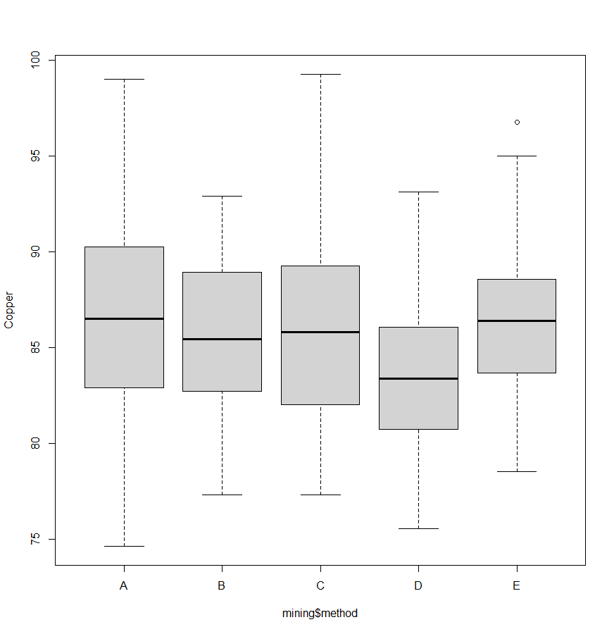

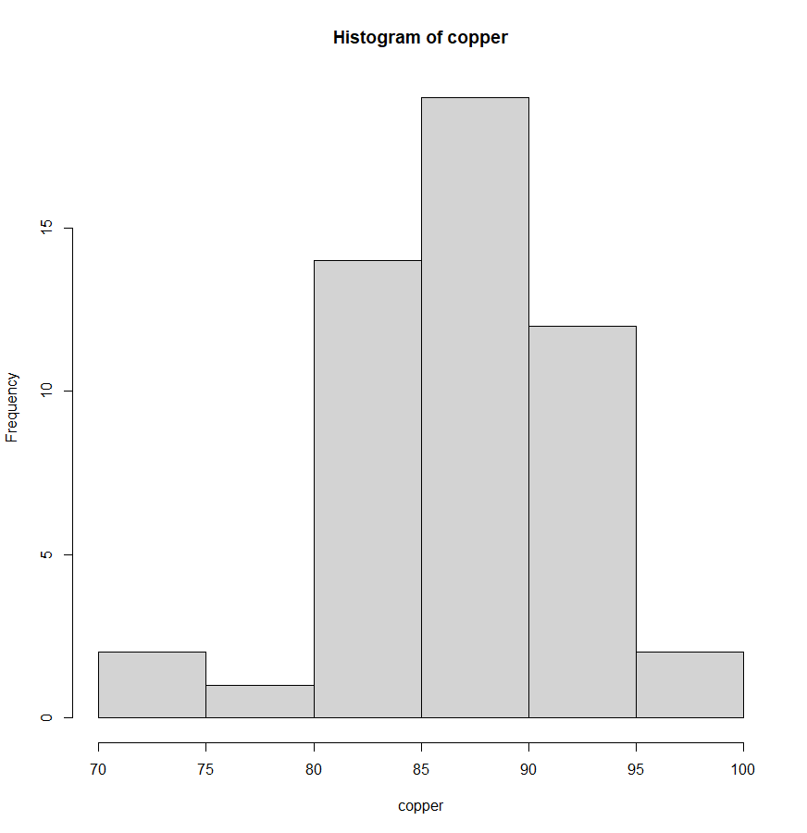
Method B
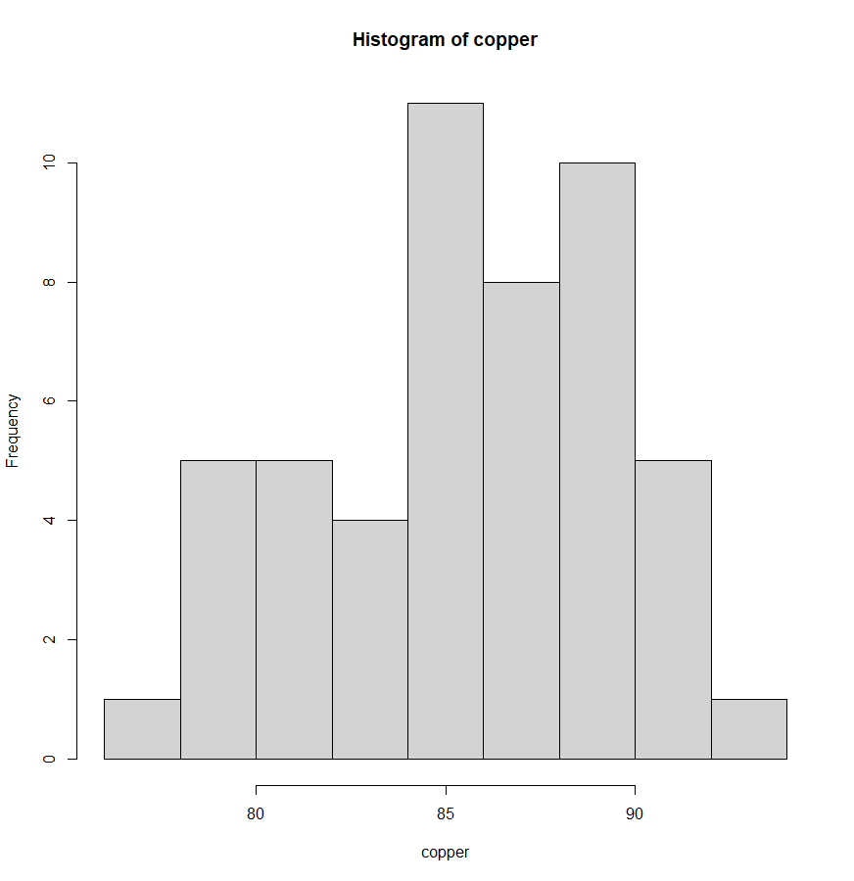
Method c
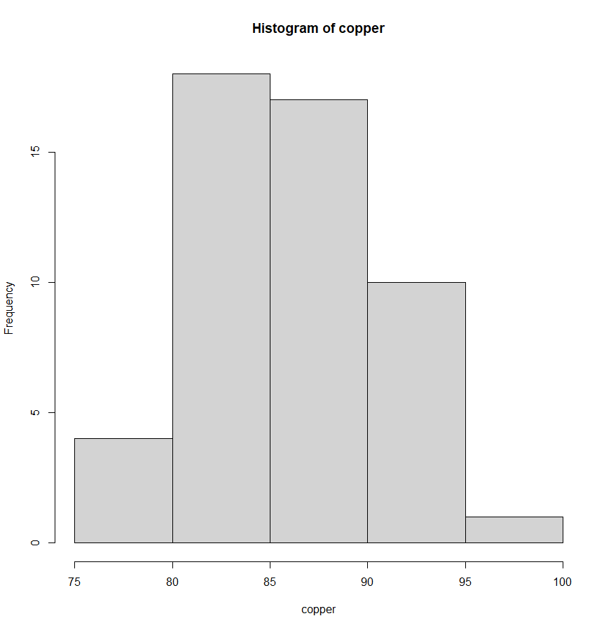Method D

Method E
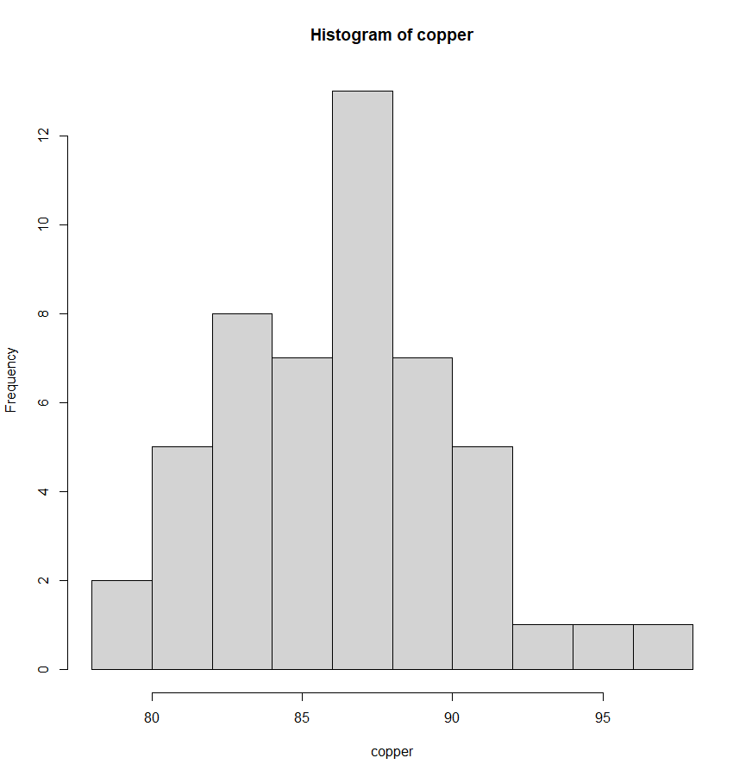

The boxplots and histograms indicate that there are one outliers for E and there is some evidence of strong skew.NO wchecking with fligner test

HOMOGENEITY TEST –
Hypothesis –
#H0 = the variances crop yield for the different soil types are the same.
#HA = the variances of crop yield for the different soil types are not the same.

data: mining$copper by mining$method
Fligner-Killeen:med chi-squared = 6.5993, df = 4, p-value = 0.1586
The p-value is 0.1586 which is greater than 0.05, so we fail to reject the null hypothesis and conclude that there is not enough evidence to suggest that the variance across the different method is different. Homogeneity of variance has been satisfied and we may proceed with the ANOVA

ANOVA TABLE
 | d.f. | Sum Sq | Mean Sq | F- Value | p-value
Display | 4 | 241 | 60.18 | 3.182 | >0.01 / 0.0412
Residuals | 245 | 4633 | 18.91

Eta square E = SSf/ SSt,
E = 4633/241+4633
E = 0.950
It measures the proportion of the total variance in the response variable associated with the changes in explanatory variable, and can say E is the is the percent of variation.

Since,
If p-value<0.05 or alpha, we reject H0
If p-value>0.05 or alpha, we fail to reject H0

A one way analysis of variance indicated that the method used has a significant effect on the percentage of copper recovered from the ore, F-value = 3.182, MSE = 18.91, p = 0.0412, η² /E = 0.950
The fitted model for
Coefficients:
Estimate Std. Error t value Pr(>|t|)
(Intercept) 86.7694 0.6150 141.097 < 2e-16 ***
Is
Y = 86.76-1.34a-1.04b-2.85c-0.40

Pairwise comparisons including a table 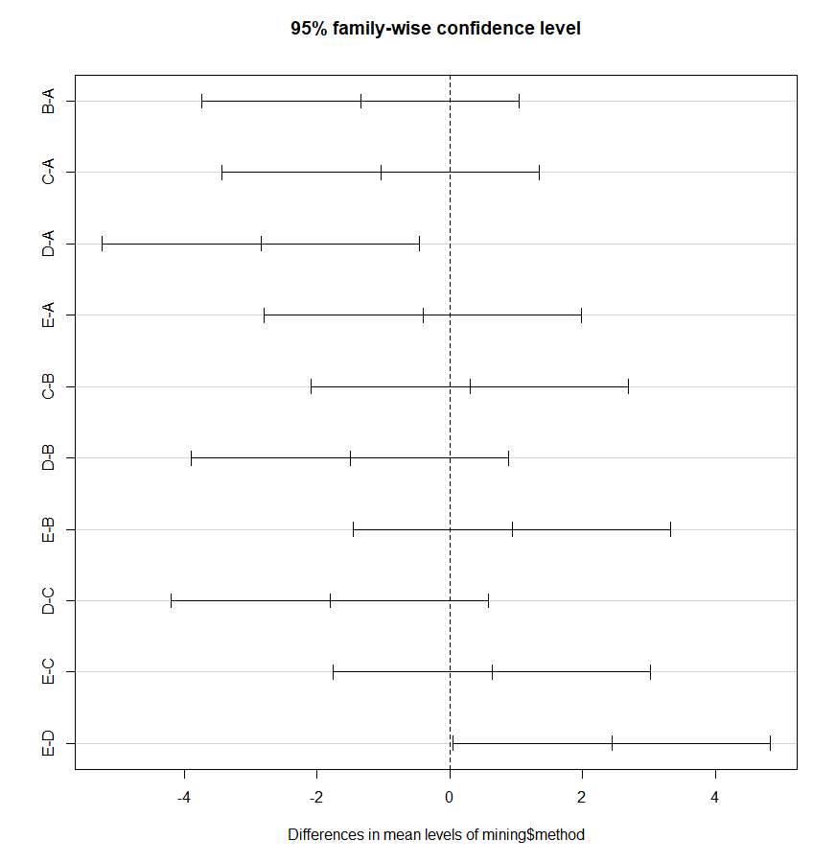
We can observe that there is mean percentage was significantly different only for pair of methods E and D.

So,
86.8
85.4
85.7
83.9
86.4

Using the output from the treatment effects we can write:

$${\hat{y}}_{ij}={\hat{β}}_{0}+{\hat{β}}_{1}x_{1}+{\hat{β}}_{2}x_{2}$$
$${\hat{y}}_{ij}=86.8-1.4x_{1}-1.1x_{2 }-2.9x3-0.4x4$$

Where for the method A, $x_{1}=0$, and $x_{2}=0$, x3 = 0, x4=0.
For method B $x_{1}=1$ $x_{2}=0$, x3 = 0, x4=0.
For method C $x_{1}=0$, and $x_{2}=1$, x3 = 0, x4=0.
For method D $x_{1}=0$, and $x_{2}=0$, x3 = 1, x4=0.
For method E $x_{1}=0$, and $x_{2}=0$, x3 = 0, x4=1.

Tukey’s HSD test indicated that the mean number of cases sold was significantly different between all designs except between methods and E and D.
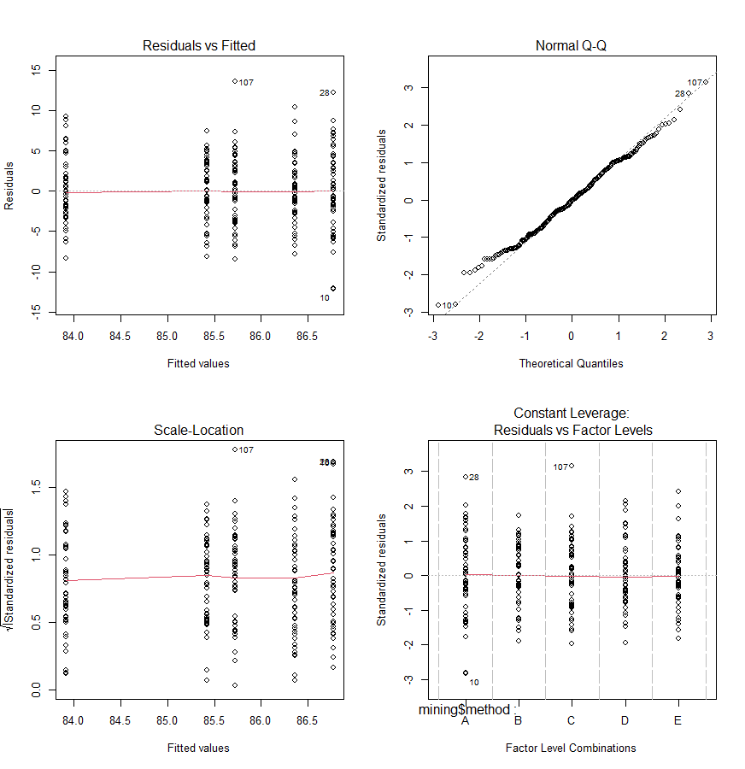
Model diagnostic plots indicate that the residual terms have a normal distribution and that homogeneity of variance across treatment groups is satisfied, with no influential points.

Question 2
Answer a).
Mean is 55.42
Sd is 23.98

b)
sample size is 53 as per power test.

